**SHRUTHI .T.R**

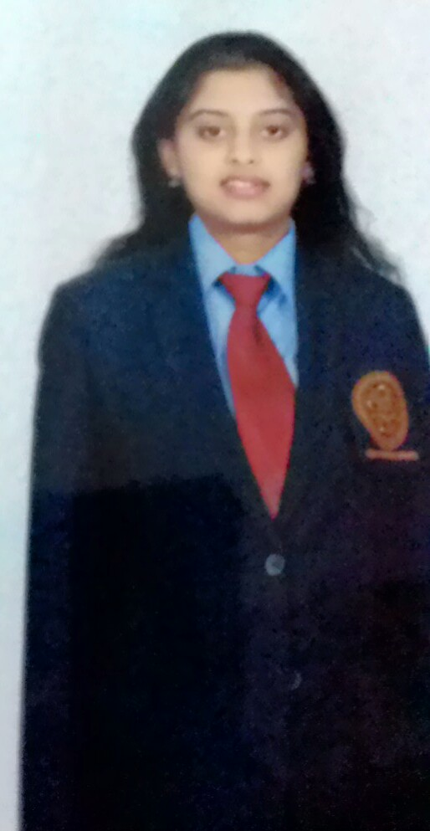

**PERSONAL DETAILS**

Date of Birth : 2nd of September 1990

Nationality : Indian

Marital Status : Married

Languages Known : English (Fluent), Kannada (Fluent), Hindi (Intermediate), Tamil (Intermediate)

Personal No : +66619179720

E-Mail : ramesh.shruthi6@gmail.com

Address : 11/10, Blue Ocean Condo, Longhad Bangsaen Road, Chonburi, Thailand

**CAREER OBJECTIVE**

* To find a challenging position to meet my competencies, capabilities, skills, education and experience.
* Possess professional qualities resulting in better financial performance and enhanced systems for higher performance of the organisation.

**FIELD OF INTEREST**

##### HR in Recruitment domain

**EDUCATION**

* Masters in Business Administration (M.B.A) in H.R from BNM institute of technology - 2014
* Pursued Bachelor's Degree in Commerce from Vijaya College - 2012
* Pursued 12th at Vijaya College - 2008

**PROJECTS AND INTERNSHIPS**

**MBA Project ON E RECRUITMENT AT BRIGADE GROUP**

* MBA Project about E-Recruitment at 2014 at Brigade Group World Trade Center, Corporate office, Bangalore
* The analyses was based on tools with structured questionnaire
* The analyses was based on techniques like CPM, correlation, cross tabulation, one way Anova, mean, standard deviation, percentage analyses
* The findings was based on the questionnaire given to the recruiters and candidates
* The suggestion is provided to candidates, recruiters and management and non-management personnel
* Creating their own job portal, Online advertising, online questionnaire for preliminary analyses are major suggestions given to brigade group
* The findings, suggestions and hypotheses was based on the objectives
* The result was positive towards the findings and the objectives

**PROFFESIONAL EXPERIENCE**

* **I possess an overall 1.4 years of relevant industrial experience**

**Accenture: 6 months**

**PROJECT ER IDC: Project released September 2015**

**Key roles and responsibilities:**

* End to end for ER Project processing
* Managing reports, data, trackers followed by the dump produced
* Handled Sourcing, screening, scheduling, OPDP allocations
* Handled Adhoc status, offline, online status, ECAF, Candidate range cases, salary negotiation
* Handled Compensation mismatch, notice period issues, adhoc meetings
* Handled The tagging and untagging system in abacus tool
* Handled IT positions for programmer,developer,testers profiles
* Handled recruiting profiles for the client requirements and close positions
* Handled HR database and personnel records required to maintain the performance

**IFocus systec :6 months**

**PROJECT :IOS app testers and developers: Project released February 2015**

**Key roles and responsibilities at iFocus Systec:**

* Job role: End to End Recruitment process as a junior recruiter for technical requirement
* Understanding the job descriptions and requirements of the **clients like GE, Sony, Mccafe ,Philips**
* sourcing ,screening, scheduling the candidates for testing and developers field on the basis of client requirements
* Short listing and closing the positions for the client requirements
* Outcome was positive towards the challenging targets which was achieved
* Closed positions and reached target given by the client side for testers and developer positions with experienced candidates around 8 to 10 years

**Brigade Group:4 months**

**Key roles and responsibilities**

* The overall knowledge about on- boarding and joining details
* Processing offer letter, appointment letter, joining letter
* End to end knowledge about hr recruitment process
* Document verification, biometrics and payroll activities
* Good communication skills to the clients and the candidates
* Knowledge about database, training and development, administrative activities

**CERTIFICATIONS**

* Stanford university venture lab: Creative Management, Risk Management
* ICICI direct stock minds –trading program.

**ACHIEVEMENTS**

* Active coordinator in NHRD project Swayamvar for January 2014 in BNMIT
* Was co-coordinator of psychometric test in psychometric santé and panel discussion conducted in BNMIT-2014
* Organizer of the cultural team in the college FEST AROHAN 2013 in BNMIT
* Won as a best trader from ICICI direct- stock mind held in 2013

**INDUSTRIAL VISITS**

* Schneider Electrical Company – 2013. A week program held regarding HR drawbacks and how to solve them.

**IT SKILLS**

* SPSS, MS Excel
* Tally-Accounting package
* MS Office package

**Declaration**

I assure you that above information given are true to the best of my knowledge and belief. If provided an opportunity, i will utilize it with all my determination to be a committed professional dedicated to the cause of the organization.

Shruthi T R